**Applied Algorithms: Benchmarking and Determining Functions**

Norvin Lim

Computing & IT program, British Columbia Institute of Technology

ACIT-3896: Applied Algorithms

Jeremy Holman

February 9, 2024

Contents

Analysis 3

Routine 1 3

Routine 2 3

Routine 3 3

Routine 4 3

Routine 5 3

Code 3

Terminal Output(s) 4

Routine 1 4

Routine 3 5

Routine 4 5

Routine 5 6

Additional Notes 6

# Analysis

## Routine 1

## Routine 2

## Routine 3

## Routine 4

## Routine 5

# Code

I chose to not attach code per routine in the document and at my own discretion created a GitHub repository that contains the modified routines and terminal outputs for each routine all named.

<https://github.com/HawkOverHK/Applied-Algo-Assignment-1>

# Terminal Output(s)

Please note that all Terminal Outputs/Results are displaying the “Mean Runtime” in Nanoseconds. Results, Data and Graphs will be rounded up to be in Milliseconds

## Routine 1

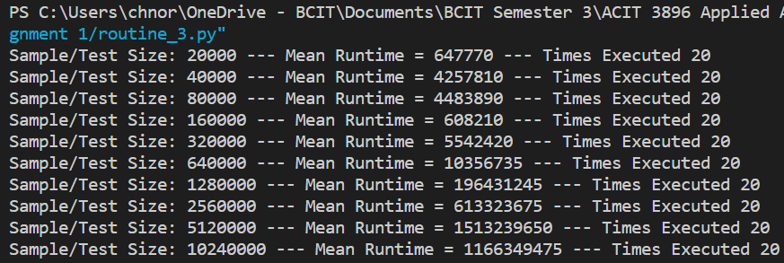Routine 2

Note that I ran Routine 2 twice and will have 2 sets of data and graphs to correspond to each one.

## Routine 3

## Routine 4

## Routine 5

# Additional Notes